CONSTRAINT-BASED PROBLEM SOLVING
University Final Examination Scheduling Using CSP

Problem Description
A university must schedule five final examinations—Artificial Intelligence (A), Database Systems (B), Computer Networks (C), Operating Systems (D), and Software Engineering (E)—into three slots: Slot1, Slot2, and Slot3. Conflicting courses share students and therefore must be assigned different slots.
Conflicting pairs: A–B, A–C, B–C, B–D, C–D, C–E, and D–E.

(a) PEAS Description
PEAS component | Description
Performance measure | Assign every course a slot; satisfy all conflict constraints; avoid clashes; produce a valid timetable with minimal search effort.
Environment | Five courses (A–E), three exam slots, student-enrollment overlaps, and the listed conflict constraints.
Actuators | Assign or revise a course’s slot; maintain and output the timetable.
Sensors | Read course data, available slots, enrollment-conflict information, current assignments, and domain/constraint status.

(b) Type of Intelligent Agent
A goal-based agent is best suited to this task. It searches for an assignment that reaches the goal state: every course has one slot and no conflicting pair shares a slot. It can compare candidate assignments against the constraints and backtrack when a choice prevents completion. A simple reflex agent lacks sufficient search over future consequences; a model-based agent can represent the state but does not, by itself, specify the goal-directed search; and a utility-based agent is unnecessary because any conflict-free timetable is acceptable and no preference among valid timetables is given.

(c) Constraint Satisfaction Problem (CSP) Model
Variables: A, B, C, D, E, one variable for each course.
Domains: D(A) = D(B) = D(C) = D(D) = D(E) = {Slot1, Slot2, Slot3}.
Constraints: Each listed conflicting pair must have different values: A ≠ B, A ≠ C, B ≠ C, B ≠ D, C ≠ D, C ≠ E, and D ≠ E.
Constraint graph: Vertices are {A, B, C, D, E}. An undirected edge joins each pair that must have different slots.
Vertex | Adjacent vertices
A | B, C
B | A, C, D
C | A, B, D, E
D | B, C, E
E | C, D

The graph edges are: {(A,B), (A,C), (B,C), (B,D), (C,D), (C,E), (D,E)}.

(d) Plain Backtracking Search
Use the fixed variable order A → B → C → D → E and try Slot1 → Slot2 → Slot3 for each variable. An assignment attempt is counted whenever a slot is tried for a variable. A rejected attempt violates a constraint with an already assigned variable. The trace below records each attempt, including assignments that are later undone.
Step | Variable | Tried value | Outcome | State / action
1 | A | Slot1 | Success | A = Slot1
2 | B | Slot1 | Fail: A–B | Backtrack from B; try next value
3 | B | Slot2 | Success | A = Slot1, B = Slot2
4 | C | Slot1 | Fail: A–C | Try next value for C
5 | C | Slot2 | Fail: B–C | Try next value for C
6 | C | Slot3 | Success | A = Slot1, B = Slot2, C = Slot3
7 | D | Slot1 | Success | D differs from B and C
8 | E | Slot1 | Success | E differs from C and D

Final timetable from plain backtracking:
Course | Exam slot
A — Artificial Intelligence | Slot1
B — Database Systems | Slot2
C — Computer Networks | Slot3
D — Operating Systems | Slot1
E — Software Engineering | Slot2

The search makes 8 assignment attempts and 0 chronological backtracks (there are failed value attempts, but no previously successful variable assignment needs to be undone).

(e) Backtracking Search with Forward Checking
Forward checking removes from each unassigned neighboring variable’s domain any value that conflicts with the newly assigned variable. If any unassigned domain becomes empty, the algorithm backtracks immediately. The same fixed variable and value order is used.
Step | Assignment | Domains after forward checking | Action
1 | Assign A = Slot1 | B: {Slot2, Slot3}; C: {Slot2, Slot3}; D: {Slot1, Slot2, Slot3}; E: {Slot1, Slot2, Slot3} | Continue
2 | Try B = Slot2 | C: {Slot3} after removing Slot1 (A–C) and Slot2 (B–C); D: {Slot1, Slot3} after removing Slot2 (B–D); E unchanged | Continue
3 | Assign C = Slot3 | D: {Slot1} after removing Slot3 (C–D); E: {Slot1, Slot2} after removing Slot3 (C–E) | Continue
4 | Assign D = Slot1 | E: {Slot2} after removing Slot1 (D–E) | Continue
5 | Assign E = Slot2 | All variables assigned; all constraints satisfied | Success

Note: At step 2, B = Slot1 is tried first and rejected because A–B is a conflict. Then B = Slot2 is assigned. Forward checking removes Slot1 from C due to A–C and Slot2 from C due to B–C, leaving C = {Slot3}.
Final timetable from forward checking:
Course | Exam slot
A — Artificial Intelligence | Slot1
B — Database Systems | Slot2
C — Computer Networks | Slot3
D — Operating Systems | Slot1
E — Software Engineering | Slot2

Forward-checking assignment attempts: 6 (A=Slot1; B=Slot1 rejected; B=Slot2; C=Slot3; D=Slot1; E=Slot2). There are 0 chronological backtracks because the first consistent path reaches a solution. Domain pruning prevents the search from trying values already known to be impossible for future variables.

(f) Comparison and Explanation
Measure | Plain backtracking | Backtracking + forward checking
Assignment attempts | 8 | 6
Failed value attempts | 3 (B=Slot1, C=Slot1, C=Slot2) | 1 (B=Slot1); the remaining failures are eliminated by pruning
Chronological backtracks | 0 | 0
Domain pruning | No explicit pruning of future domains | Removes values from unassigned neighbors after each assignment
Search effort | More attempts are needed to discover conflicts when a variable is reached | Lower effort because future conflicts are detected earlier

Why forward checking reduces search effort: plain backtracking checks a variable’s candidate value only when that variable is selected. Forward checking propagates the effect of each assignment to the domains of unassigned neighboring variables. For example, after A = Slot1 and B = Slot2, C is immediately restricted to {Slot3}; the algorithm does not need to test C = Slot1 and C = Slot2 separately. This early pruning reduces assignment attempts for this instance.
Conclusion: Both methods produce a valid conflict-free timetable. With the specified ordering, plain backtracking makes 8 assignment attempts, while forward checking makes 6. Neither method needs a chronological backtrack on this particular search path, but forward checking reduces the number of explicit failed attempts by detecting impossible values in advance.

Programming:
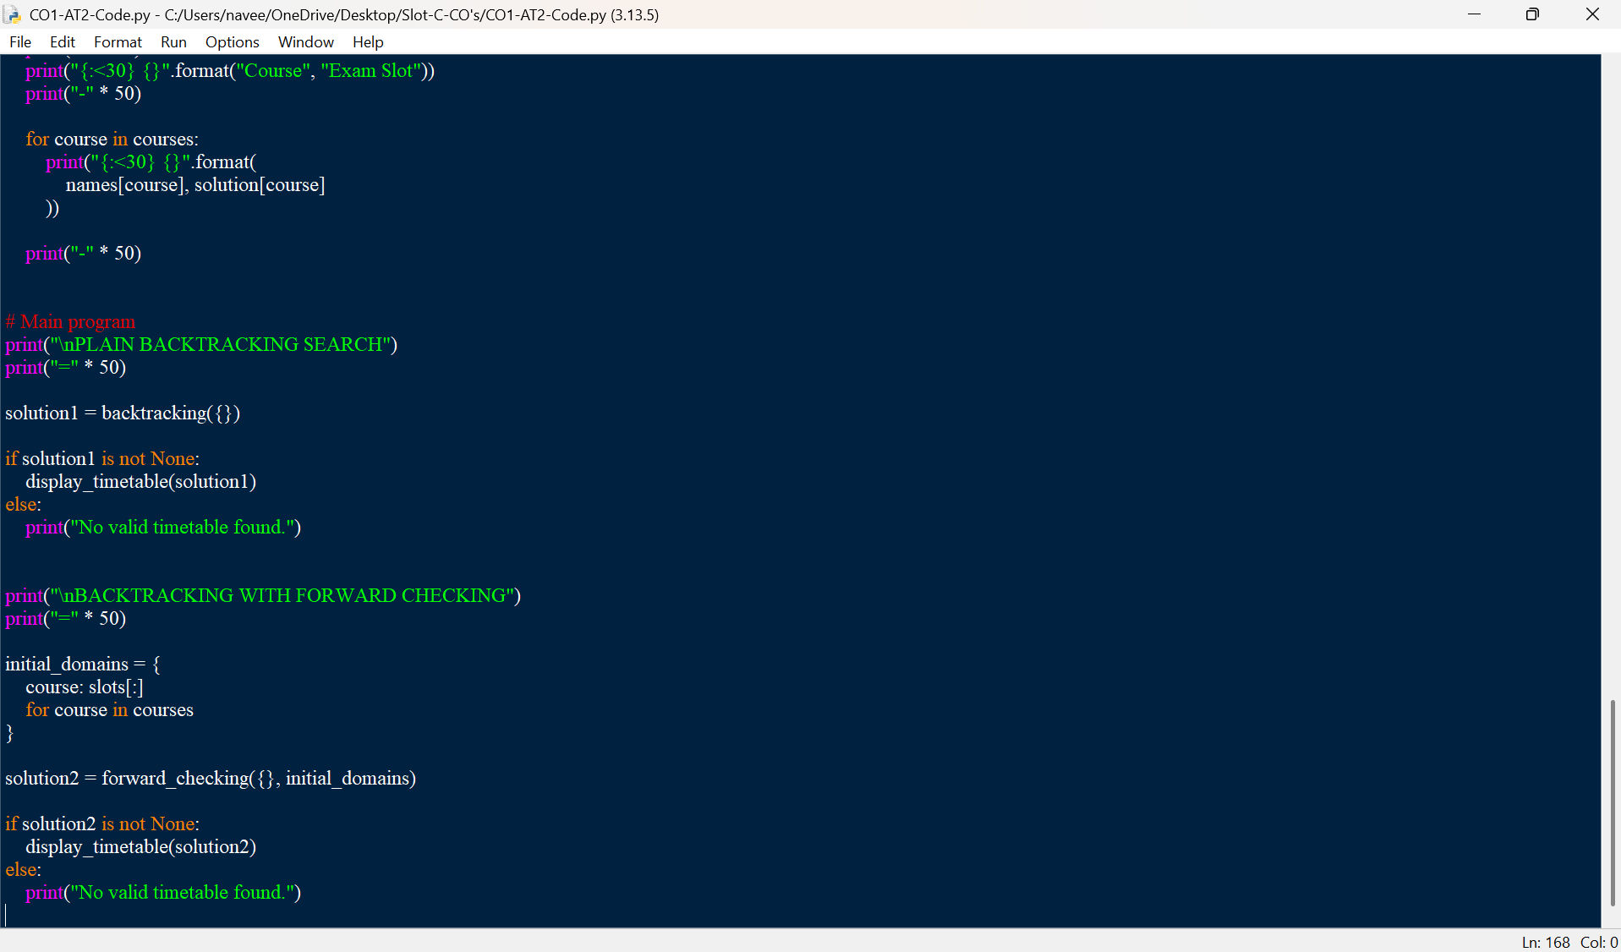
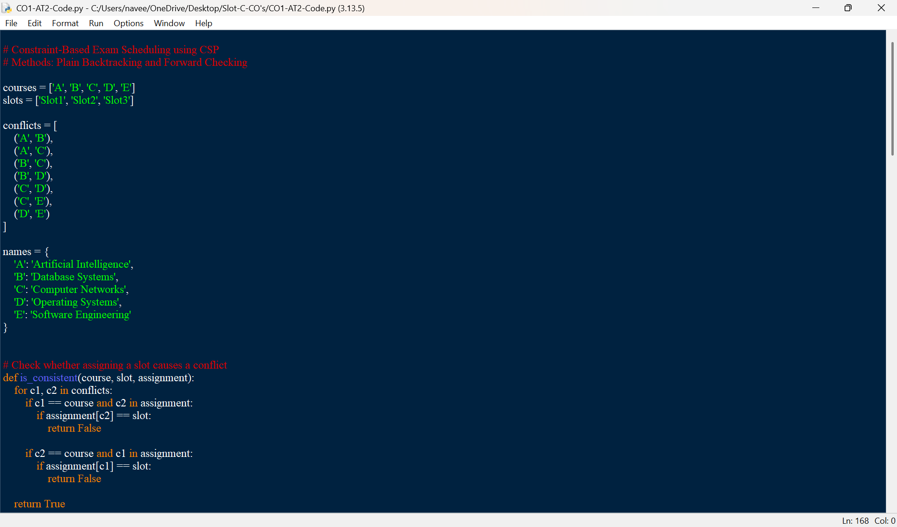
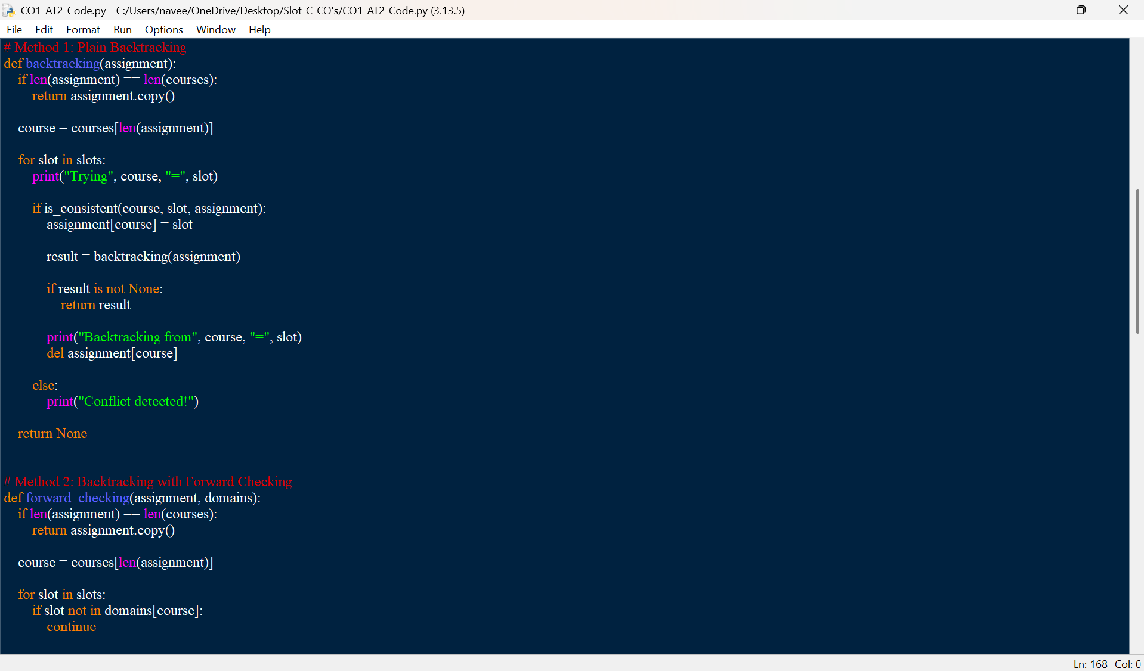
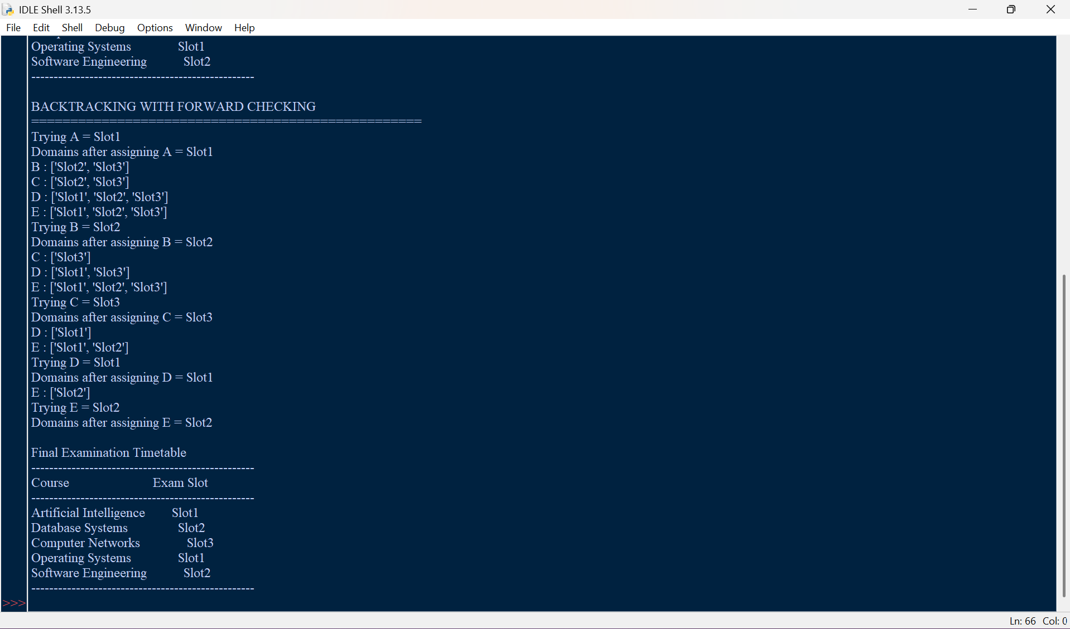
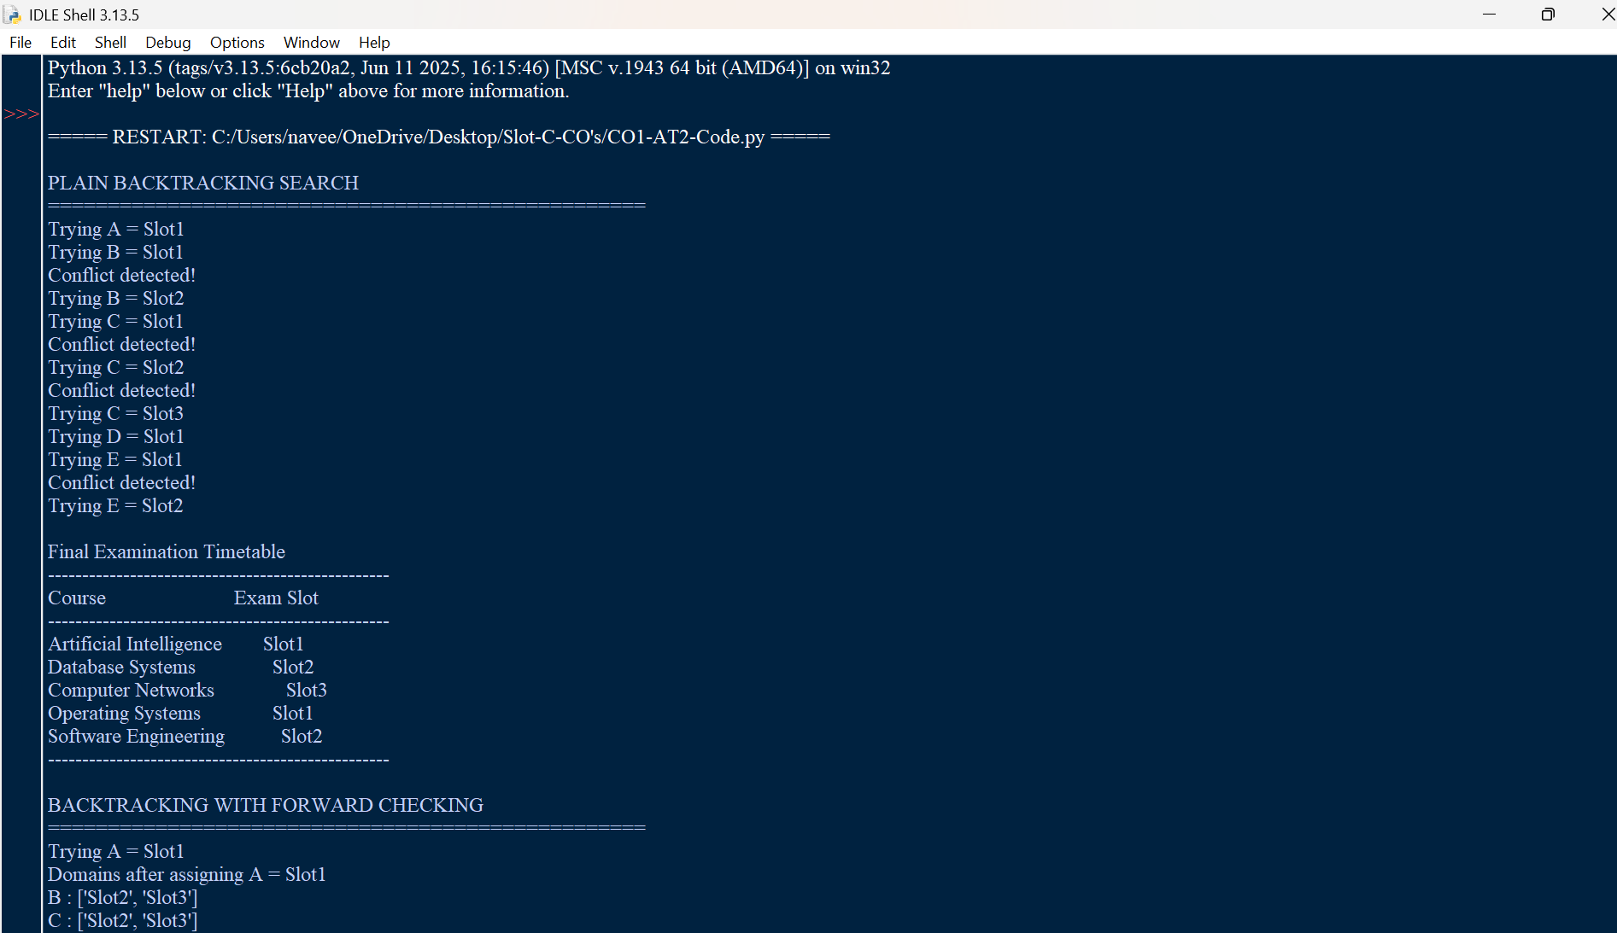
Output:

Result:
Both algorithms find a valid timetable satisfying all seven conflict constraints. Forward checking reduces unnecessary search by removing unavailable slots from the domains of unassigned courses.

